**COMPSCI 410/510 Databases (Spring 2014)**

**Programming Assignment #2 due on 03/10/2014, Monday (11PM)**

**Points 100**

**Introduction:**

In addition, to this problem definition, the assignment folder consists following:

1. A script to create the university database
2. A number of out files that contain expected results for each of the 11 subparts of the question.

This assignment asks you to write 11 SQL queries to retrieve information from the university database created using university-schema.sql script file.

You may copy the files from onyx.boisestate.edu

/home/faculty/vijaydialani/cs410/assignment-2

**Description:**

The 11 queries are listed below. Please name your script files Q1.sql, Q2.sql,..., Q11.sql for the queries.

1. Retrieve the names of all students who major in computer science department.
2. Retrieve the names of all students who didn’t take any course from computer science department.
3. For each college, count the number of sections offered by that college.
4. Retrieve the names of students who only took courses from his major departments.
5. Retrieves the names of students whose accumulated credit hours is greater than or equal to 10 (Only passed courses will be counted; A passed course means the student get a grade C or above).
6. Retrieve the names of departments, which offered at least 2 courses (not sections) in spring, 2001.
7. For each student having taken courses from his/her minor departments, retrieve the student name, the course name, and the corresponding grade the student received.
8. Retrieve the name of each student if the student claims a minor in a college, which is different from the student’s major colleges.
9. Retrieve the name of each student who has claimed minor(s), but has not received any grade from any of his/her minor departments yet.
10. Retrieve the names of all students who have taken all his/her major department(s) courses. Show the result in ascending order of student’s last name, first name.
11. Retrieve the department’s names, which have more minor students than major students.

Attached is the university database schema for your quick reference.

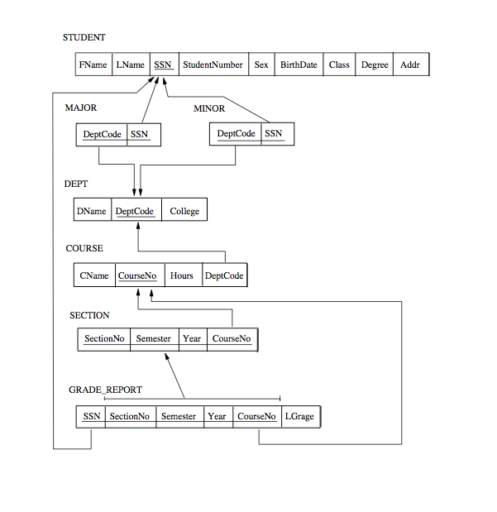

**Submission Instructions:**

Go to the folder containing your files for submission and run the following command from onyx

submit vijaydialani cs410 a2